E-commerce Sales Data Analysis Using MS Excel

Dataset Description
The dataset consists of four sheets, each representing a different business entity. These sheets are interconnected using unique IDs.

Sheet 1: Customer Data

Contains demographic and loyalty information of customers.

Sheet 2: Product Data
Contains product-related details including category, cost, and stock levels.

Sheet 3: Store Data
Contains store information such as region, city, and store type.

Sheet 4: Sales Data
Contains transaction-level sales details including quantity sold, discounts, payment type, and total amount.
Column Description
Formula used for | Formula details
Trim and Clean | =trim(clean(b2:b8))
vlookup | =VLOOKUP(Customer_ID, Customer_Data!A:H, 8, FALSE)

Customer Data → who is buying, Product Data → what is being sold
Store Data → from where it is sold, Sales Data → actual transactions
- Sales Data is the main table
- Other 3 sheets are master tables

More Diagram missing
s
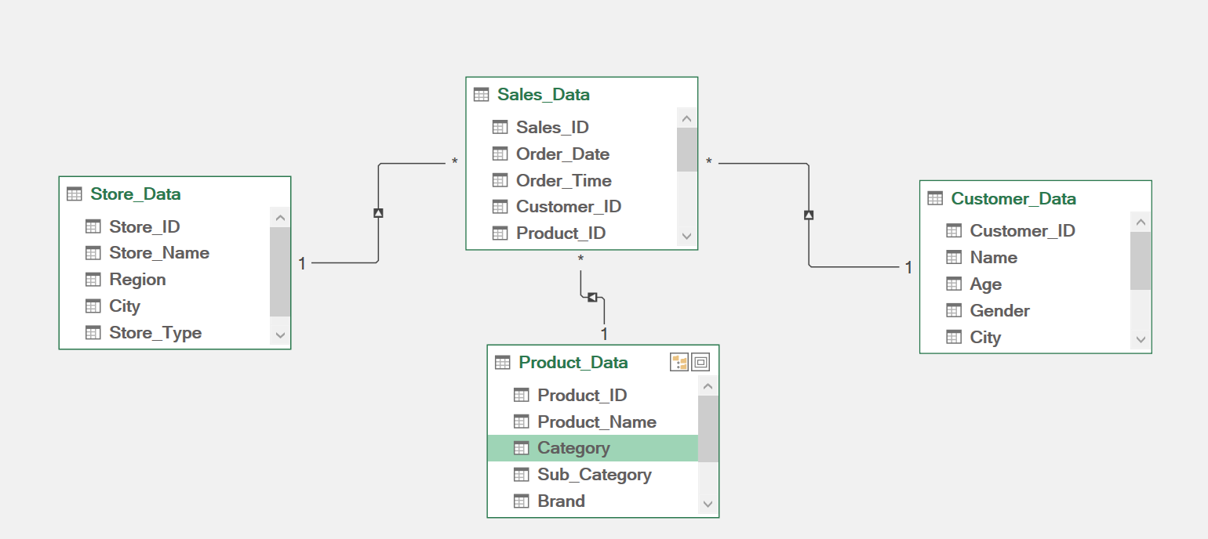
Conclusion:
This project successfully analyzed e-commerce sales data using MS Excel. The analysis provided insights into customer behavior, product demand, and store performance. Excel tools such as Pivot Tables and charts helped in effective data analysis and decision-making.

